**Leinz Sion Patterned Porcelain Paving Slabs:** 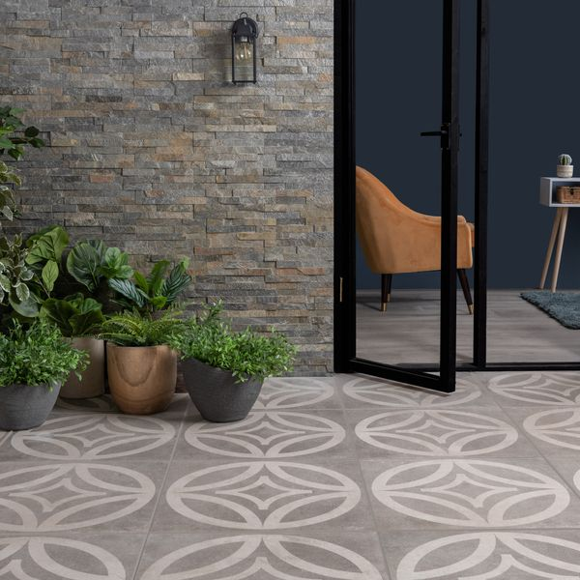

## **Product Description**

Designed with a contemporary geometric pattern on a speckled, dark grey stone effect base, these Leinz Sion Patterned Porcelain Paving Slabs are great for creating a statement look in your outdoor space. The curved, modern lines create a smooth and simple geometric design for a characterful look. These stunning tiles are the perfect choice for the popular garden trends, zoning and outdoor rugs - especially when paired with the original plain tiles from the range.

Have you seen our [20mm Paving Slab Trims](https://www.wallsandfloors.co.uk/20mm-paving-slab-trims)?

**What’s special about these tiles?**

> Durable porcelain construction

> Long-lasting and easy to clean

> Speckled, dark grey hue with modern, geometric design

> Perfect for the popular zoning and outdoor rug trends

> R11 anti-slip surface

## **Product INFO**

* Product ID: 45052
* Tiles Per SQM: 2.8246592754749
* Sale by: Per SQM
* Size: 595x595x20mm
* Weight: 13.70 KG
* Material Type: Porcelain
* Finish: Matt
* Colour: Grey
* Suitability: Floors
* Area Of Usage: External
* Grade: 4
* Rectified Edge: Yes
* Underfloor Heating: Yes
* Anti Slip Grade: R11 / 35 Degrees
* Document: [20mm Installation Guide](https://m2.wallsandfloors.co.uk/media/amasty/amfile/attach/20mm-installation-guide_4.pdf),[Cleaning and Protection Guide](https://m2.wallsandfloors.co.uk/media/amasty/amfile/attach/ltp_-_walls_floors_-_external_porcelain_-_cleaning_and_protection_guide_-_april_2020.pdf)
* Thickness (mm): 20